Regular Pentagonal Pyramid
# Source: AI Source: Provided by: [Data Path: Persons Table -> ID Column: 1, Name_En Column: Motasem Essam] -> From: [ChatGPT] on [7/25/2026]
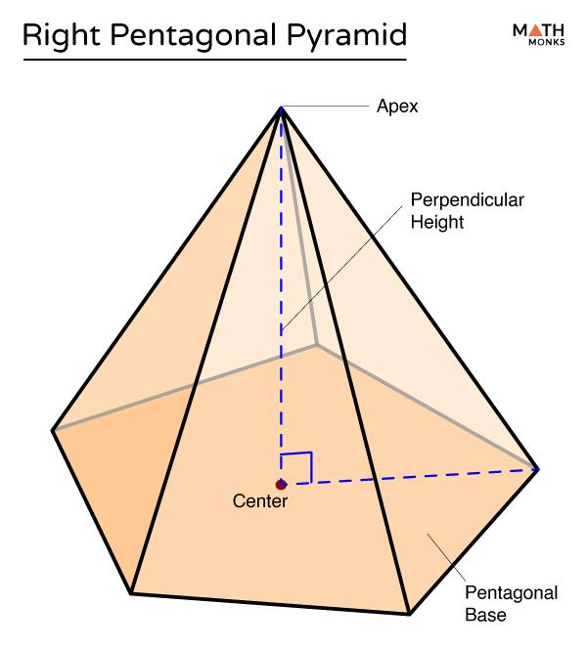
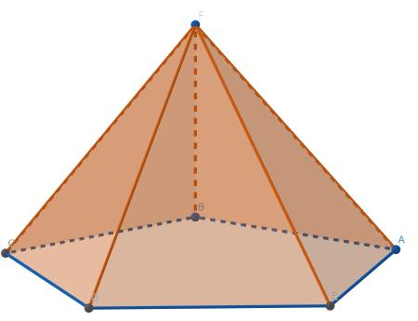
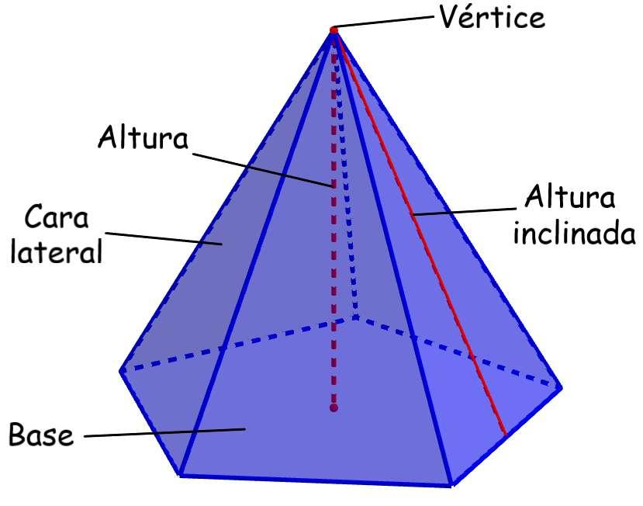

Definition
# Source: AI Source: Provided by: [Data Path: Persons Table -> ID Column: 1, Name_En Column: Motasem Essam] -> From: [ChatGPT] on [7/25/2026]
A regular pentagonal pyramid is a three-dimensional geometric solid whose base is a regular pentagon and whose apex lies directly above the center of the base.
A regular pentagon has five equal sides and five equal interior angles, each measuring ${108}^{∘}$. In a regular pentagonal pyramid, the apex is positioned so that the perpendicular height meets the base at its center. Consequently, the five lateral faces are congruent isosceles triangles.
A regular pentagonal pyramid has:
- 1 regular pentagonal base.
- 5 triangular lateral faces.
- 6 faces in total.
- 10 edges in total.
- 6 vertices in total.
It is both a pentagonal pyramid and a regular pyramid.

Simple Definition
# Source: AI Source: Provided by: [Data Path: Persons Table -> ID Column: 1, Name_En Column: Motasem Essam] -> From: [ChatGPT] on [7/25/2026]
A regular pentagonal pyramid is a pyramid with a regular five-sided base and five equal triangular side faces meeting at an apex directly above the center of the base.

Key Characteristics
# Source: AI Source: Provided by: [Data Path: Persons Table -> ID Column: 1, Name_En Column: Motasem Essam] -> From: [ChatGPT] on [7/25/2026]
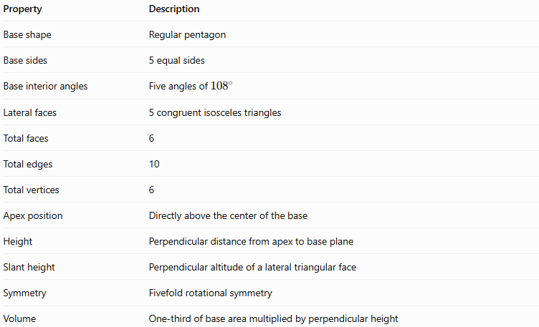
Property | Description
Base shape | Regular pentagon
Base sides | 5 equal sides
Base interior angles | Five angles of ${108}^{∘}$
Lateral faces | 5 congruent isosceles triangles
Total faces | 6
Total edges | 10
Total vertices | 6
Apex position | Directly above the center of the base
Height | Perpendicular distance from apex to base plane
Slant height | Perpendicular altitude of a lateral triangular face
Symmetry | Fivefold rotational symmetry
Volume | One-third of base area multiplied by perpendicular height

Geometric Representation
# Source: AI Source: Provided by: [Data Path: Persons Table -> ID Column: 1, Name_En Column: Motasem Essam] -> From: [ChatGPT] on [7/25/2026]
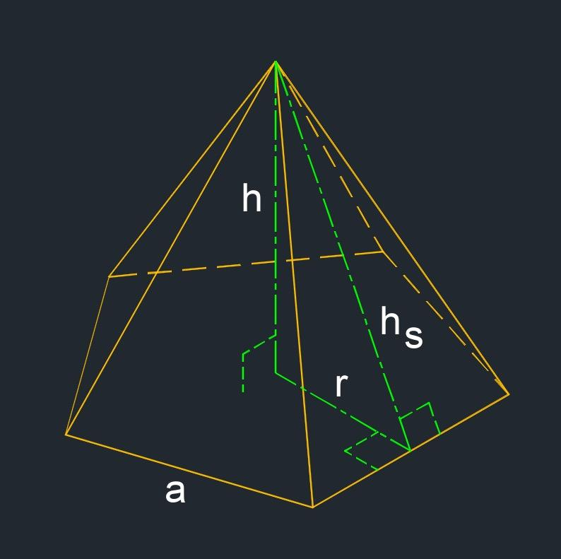
The main components are:
- Base: A regular pentagon with five equal sides and five equal interior angles.
- Apex: The point directly above the center of the pentagonal base.
- Base edges: Five equal edges forming the pentagon.
- Lateral edges: Five equal segments connecting the apex to the pentagon's vertices.
- Lateral faces: Five congruent isosceles triangles.
- Height: The perpendicular distance from the apex to the base plane.
- Slant height: The perpendicular distance from the apex to the midpoint of a base edge, measured along a lateral face.
- Base center: The common center of the regular pentagon, where its symmetry axes meet.
The lateral edges and slant height are different lengths. The lateral edge runs from the apex to a base vertex, while the slant height runs from the apex to the midpoint of a base edge.

6. Mathematical Representations and Formulas
# Source: AI Source: Provided by: [Data Path: Persons Table -> ID Column: 1, Name_En Column: Motasem Essam] -> From: [ChatGPT] on [7/25/2026]
Let:
- $a$ = side length of the pentagonal base.
- $H$ = perpendicular height of the pyramid.
- $B$ = area of the base.
- $P$ = perimeter of the base.
- $r$ = apothem of the pentagonal base.
- $l$ = slant height of a lateral face.
- $R$ = circumradius of the pentagonal base.

Base Perimeter
# Source: AI Source: Provided by: [Data Path: Persons Table -> ID Column: 1, Name_En Column: Motasem Essam] -> From: [ChatGPT] on [7/25/2026]
A regular pentagon has five equal sides:
$$\boxed{P=5a}$$

Base Area
# Source: AI Source: Provided by: [Data Path: Persons Table -> ID Column: 1, Name_En Column: Motasem Essam] -> From: [ChatGPT] on [7/25/2026]
The area of a regular polygon is half its perimeter multiplied by its apothem:
$$B=\frac{1}{2}Pr$$
For a regular pentagon:
$$\boxed{B=\frac{5}{2}ar}$$
Using only the side length $a$, the area can also be written as:
$$\boxed{B=\frac{a^{2}}{4}\sqrt{25+10\sqrt{5}}}$$

Apothem
# Source: AI Source: Provided by: [Data Path: Persons Table -> ID Column: 1, Name_En Column: Motasem Essam] -> From: [ChatGPT] on [7/25/2026]
The apothem is the perpendicular distance from the center of the regular pentagon to one of its sides.
$$\boxed{r=\frac{a}{2{\tan{36}}^{∘}}}$$

Circumradius
# Source: AI Source: Provided by: [Data Path: Persons Table -> ID Column: 1, Name_En Column: Motasem Essam] -> From: [ChatGPT] on [7/25/2026]
The circumradius is the distance from the center of the base to any pentagon vertex.
$$\boxed{R=\frac{a}{2{\sin{36}}^{∘}}}$$

Slant Height
# Source: AI Source: Provided by: [Data Path: Persons Table -> ID Column: 1, Name_En Column: Motasem Essam] -> From: [ChatGPT] on [7/25/2026]
For a regular pentagonal pyramid, the apex lies above the base center. The height, base apothem, and slant height form a right triangle:
$$l^{2}=H^{2}+r^{2}$$
Therefore:
$$\boxed{l=\sqrt{H^{2}+r^{2}}}$$

Lateral Surface Area
# Source: AI Source: Provided by: [Data Path: Persons Table -> ID Column: 1, Name_En Column: Motasem Essam] -> From: [ChatGPT] on [7/25/2026]
Each lateral face is a triangle with base $a$ and altitude $l$. The total lateral surface area is:
$$A_{L}=5\left(\frac{1}{2}al\right)$$
Thus:
$$\boxed{A_{L}=\frac{5}{2}al=\frac{1}{2}Pl}$$

Total Surface Area
# Source: AI Source: Provided by: [Data Path: Persons Table -> ID Column: 1, Name_En Column: Motasem Essam] -> From: [ChatGPT] on [7/25/2026]
The total surface area is the base area plus the lateral surface area:
$$\boxed{A_{T}=B+A_{L}}$$
Equivalently:
$$\boxed{A_{T}=\frac{5}{2}ar+\frac{5}{2}al}$$

Volume
# Source: AI Source: Provided by: [Data Path: Persons Table -> ID Column: 1, Name_En Column: Motasem Essam] -> From: [ChatGPT] on [7/25/2026]
The volume of any pyramid is one-third of its base area multiplied by its perpendicular height:
$$\boxed{V=\frac{1}{3}BH}$$
For a regular pentagonal base:
$$\boxed{V=\frac{5}{6}arH}$$

Euler’s Formula
# Source: AI Source: Provided by: [Data Path: Persons Table -> ID Column: 1, Name_En Column: Motasem Essam] -> From: [ChatGPT] on [7/25/2026]
For a convex regular pentagonal pyramid:
$$V_{e}-E+F=2$$
Substituting the counts:
$$6-10+6=2$$
Here, $V_{e}$ is the number of vertices, not the volume.

Worked Examples
# Source: AI Source: Provided by: [Data Path: Persons Table -> ID Column: 1, Name_En Column: Motasem Essam] -> From: [ChatGPT] on [7/25/2026]
Example 1: Finding the Base Perimeter
A regular pentagonal pyramid has a base side length of $6\text{ cm}$. Find the perimeter of its base.
Using:
$$P=5a$$
$$P=5\left(6\right)$$
$$\boxed{P=30\text{ cm}}$$
Example 2: Finding the Base Area
A regular pentagonal base has side length $4\text{ cm}$. Find its area.
Using:
$$B=\frac{a^{2}}{4}\sqrt{25+10\sqrt{5}}$$
Substitute $a=4$:
$$B=\frac{16}{4}\sqrt{25+10\sqrt{5}}$$
$$B=4\sqrt{25+10\sqrt{5}}$$
Therefore:
$$\boxed{B≈27.53{\text{ cm}}^{2}}$$
Example 3: Finding the Slant Height
A regular pentagonal pyramid has a perpendicular height of $12\text{ cm}$ and a base apothem of $5\text{ cm}$. Find its slant height.
Using:
$$l=\sqrt{H^{2}+r^{2}}$$
$$l=\sqrt{{12}^{2}+5^{2}}$$
$$l=\sqrt{144+25}$$
$$\boxed{l=13\text{ cm}}$$
Example 4: Finding the Volume
A regular pentagonal pyramid has a base area of $50{\text{ cm}}^{2}$ and a perpendicular height of $9\text{ cm}$. Find its volume.
Using:
$$V=\frac{1}{3}BH$$
$$V=\frac{1}{3}\left(50\right)\left(9\right)$$
$$\boxed{V=150{\text{ cm}}^{3}}$$
Example 5: Finding the Lateral Surface Area
A regular pentagonal pyramid has a base side length of $6\text{ cm}$ and a slant height of $10\text{ cm}$. Find its lateral surface area.
Using:
$$A_{L}=\frac{1}{2}Pl$$
First, find the perimeter:
$$P=5\left(6\right)=30\text{ cm}$$
Then:
$$A_{L}=\frac{1}{2}\left(30\right)\left(10\right)$$
$$\boxed{A_{L}=150{\text{ cm}}^{2}}$$

Comparison with Related Pyramids
# Source: AI Source: Provided by: [Data Path: Persons Table -> ID Column: 1, Name_En Column: Motasem Essam] -> From: [ChatGPT] on [7/25/2026]
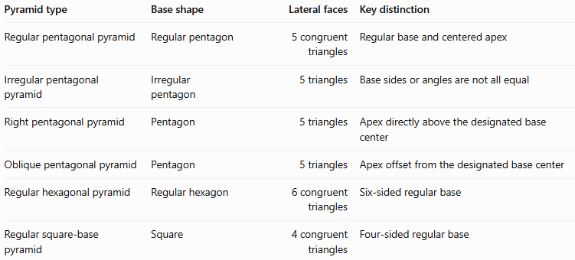
Pyramid type | Base shape | Lateral faces | Key distinction
Regular pentagonal pyramid | Regular pentagon | 5 congruent triangles | Regular base and centered apex
Irregular pentagonal pyramid | Irregular pentagon | 5 triangles | Base sides or angles are not all equal
Right pentagonal pyramid | Pentagon | 5 triangles | Apex directly above the designated base center
Oblique pentagonal pyramid | Pentagon | 5 triangles | Apex offset from the designated base center
Regular hexagonal pyramid | Regular hexagon | 6 congruent triangles | Six-sided regular base
Regular square-base pyramid | Square | 4 congruent triangles | Four-sided regular base
Important distinction: A regular pentagonal pyramid is a right pyramid with a regular pentagonal base under the standard definition. A pentagonal pyramid with an irregular base may be right or oblique, depending on its apex position.

Applications
# Source: AI Source: Provided by: [Data Path: Persons Table -> ID Column: 1, Name_En Column: Motasem Essam] -> From: [ChatGPT] on [7/25/2026]
Regular pentagonal pyramids are useful in:
- Architecture: Designing decorative roof forms, monuments, and geometric structures.
- Engineering: Modeling symmetrical tapered components.
- 3D modeling: Constructing regular polyhedral shapes in CAD and computer graphics.
- Geometry education: Studying regular polygons, symmetry, slant height, surface area, and volume.
- Mathematical design: Exploring fivefold rotational symmetry and the relationship between polygon geometry and three-dimensional solids.

Key Points
# Source: AI Source: Provided by: [Data Path: Persons Table -> ID Column: 1, Name_En Column: Motasem Essam] -> From: [ChatGPT] on [7/25/2026]
- A regular pentagonal pyramid has a regular pentagon as its base.
- It has 6 faces, 10 edges, and 6 vertices.
- Its five lateral faces are congruent isosceles triangles.
- Its apex lies directly above the center of the base.
- The base perimeter is $P=5a$.
- The base area is $B=\frac{1}{2}Pr$.
- The slant height is $l=\sqrt{H^{2}+r^{2}}$.
- The lateral surface area is $A_{L}=\frac{1}{2}Pl$.
- The volume is $V=\frac{1}{3}BH$.
- It has fivefold rotational symmetry about the axis through the apex and base center.

Conclusion
# Source: AI Source: Provided by: [Data Path: Persons Table -> ID Column: 1, Name_En Column: Motasem Essam] -> From: [ChatGPT] on [7/25/2026]
A regular pentagonal pyramid is a regular pyramid with a five-sided regular polygon as its base. Its defining characteristics are five equal base sides, five equal base angles, a centered apex, and five congruent triangular lateral faces.
It has six faces, ten edges, and six vertices. Its geometry allows the base area, slant height, lateral surface area, total surface area, and volume to be calculated using established formulas. It is also an important example for studying polygonal symmetry and the relationship between two-dimensional and three-dimensional geometry.

